*Reference: Train scheduling for minimizing passenger waiting time with time-dependent demand and skip-stop patterns: Nonlinear integer programming models with linear constraints*

Huimin Niu, Xuesong Zhou, Ruhu Gao

Problem Statement

This paper focuses on how to minimize the total passenger waiting time at stations by computing and adjusting train timetables for a rail corridor with given time-varying origin-to-destination passenger demand matrices. Given predetermined train skip-stop patterns, a unified quadratic integer programming model with linear constraints is developed to jointly synchronize effective passenger loading time windows and train arrival and departure times at each station.

1. **Notations**

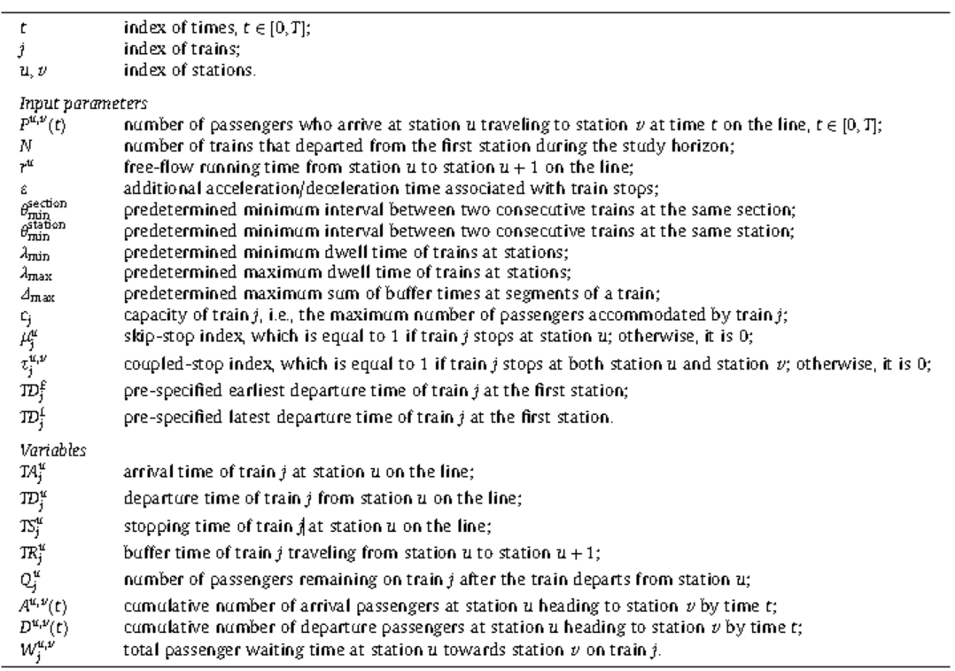

1. **Binary variables for low-resolution model**

$$β_{j^{'},j}^{u,v}=1, if train j^{'} has the same couple stop pattern \left(τ_{j^{'}}^{u,v}=τ_{j}^{u,v}=1\right)in terms of OD(u,v)$$

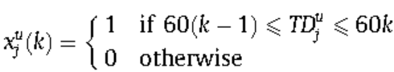

1. **Other variables for low-resolution model**



1. **Low-resolution demand model summary**

*Attention: Assuming that train j and dummy train at either the same time period or adjacent time periods*

1. Objective function- minimize total waiting time: *Equation-(1)*

$${W_{j}^{u,v}=0.5∙τ_{j}^{u,v}∙\sum_{k=1}^{K}{p^{u,v}\left(k\right)∙ }\left\{x_{j}^{u}\left(k\right)∙\left[{TD}_{j}^{u}-60\left(k-1\right)\right]+\left[\sum_{j^{'}=1}^{N}{β_{j^{'},j}^{u,v}}∙x_{j^{'}}^{u}\left(k\right)∙\left(60\left(k\right)-{TD}_{j^{'}}^{u}\right)\right]\right\}}^{2}$$

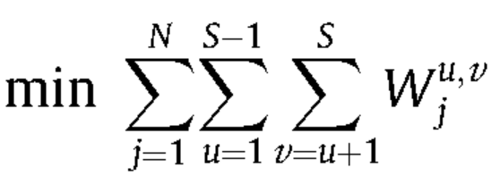

*Equation-(2)*

*Equation-(3)*

1. Train capacity constraints

$${Q_{j}^{u,v}=τ_{j}^{u,v}∙\sum_{k=1}^{K}{p^{u,v}\left(k\right)∙ }\left\{x_{j}^{u}\left(k\right)∙\left[{TD}_{j}^{u}-60\left(k-1\right)\right]+\left[\sum_{j^{'}=1}^{N}{β_{j^{'},j}^{u,v}}∙x_{j^{'}}^{u}\left(k\right)∙\left(60\left(k\right)-{TD}_{j^{'}}^{u}\right)\right]\right\}}^{ }$$

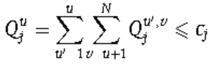

*Equation-(4)*

Scenario-1: train-j and train- $\overline{j}$ within same time period-k

*Equation-(5)*

$x_{j}^{u}(k)$ =1 *and $x_{\overline{j}}^{u}(k)=\sum_{j^{'}=1}^{N}{β_{j^{'},j}^{u,v}}∙x_{j^{'}}^{u}\left(k\right)=1$*

$${Q_{j}^{u,v}=τ_{j}^{u,v}∙\sum_{k=1}^{K}{p^{u,v}\left(k\right)∙x_{j}^{u}\left(k\right)}∙({TD}_{j}^{u}-\sum_{j^{'}=1}^{N}{β_{j^{'},j}^{u,v}}∙{TD}_{j^{'}}^{u})}^{ }$$

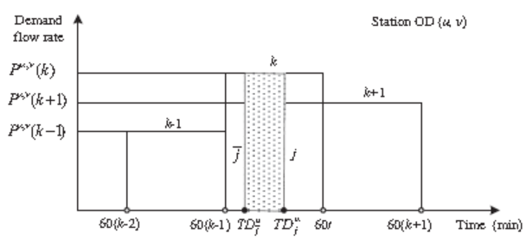

Scenario-2: train-j and train- $\overline{j}$ within different time period-k and k-1

*Equation-(6)*

For k, $x_{j}^{u}\left(k\right)-x_{\overline{j}}^{u}\left(k\right)=1 when train j stop station u within k^{th} period$

$$Q_{j}^{u,v}=τ_{j}^{u,v}∙{\sum_{k=1}^{K}{p^{u,v}\left(k\right)∙ }x}_{j}^{u}\left(k\right)∙\left[{TD}_{j}^{u}-60\left(k-1\right)\right]+τ_{j}^{u,v}∙\sum_{k=1}^{K}{p^{u,v}\left(k\right)∙\left[\sum_{j^{'}=1}^{N}{β_{j^{'},j}^{u,v}}∙x_{j^{'}}^{u}\left(k\right)∙\left(60\left(k\right)-{TD}_{j^{'}}^{u}\right)\right] }$$

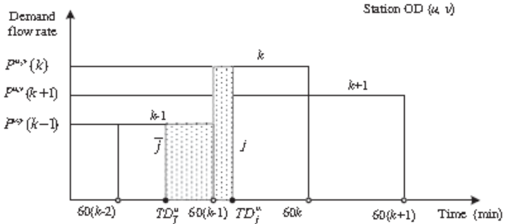

1. Other Constraints

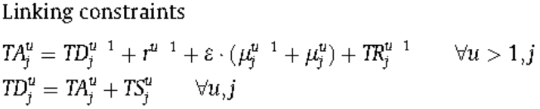

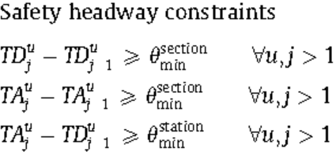

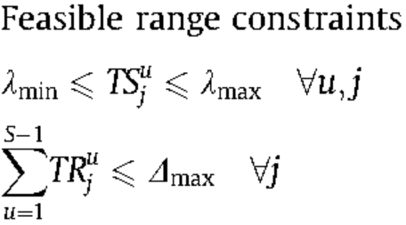

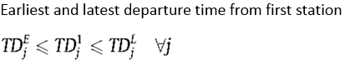

Constraints for $x_{j}^{u}(k)$

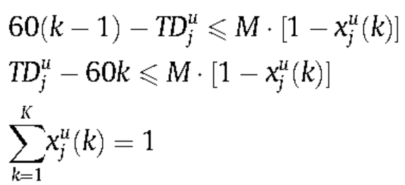

Conclusions

A unified nonlinear integer programming model with linear constraints is developed for both high-resolution and medium-resolution time-varying demand data. By introducing binary loading indicator variables, a train timetable optimization model with minute-dependent passenger demand inputs for short-term scheduling applications was formulated.